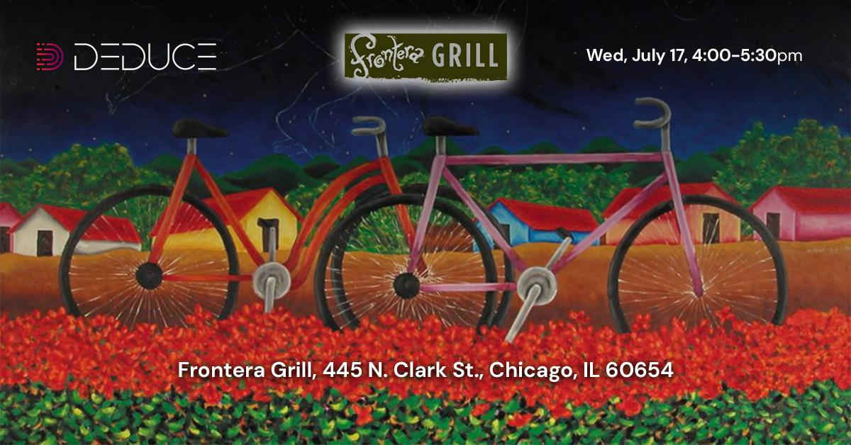

What: Please join the Deduce leadership team and your industry peers from Discover, Avant, Citi and others for drinks and appetizers

Where: Frontera Grill, 445 N. Clark St, Chicago, IL 60654

When: Wednesday, July 17, 4:00 - 5:30pm

**RSVP**

First Name

Last Name

Company

Email

Submit

*************************************************************************************************************

Email received on submission

Dear (first name);

Thank you for registering for our event. We look forward to seeing you on the 17th. Please add the event to your calendar

Buttons for iCal Outlook etc. [make sure it is set to 4:00pm CT on 17th and include title Deduce Event and the address]

Best regards

Deduce Team

*************************************************************************************************************

Reminder email sent 4:00pm Jul 16, 2024

Subject: See you tomorrow at Frontera Grill

Dear [first name];

We look forward to seeing you tomorrow at Frontera Grill, 445 N. Clark St, Chicago, IL 60654 at 4:00pm - 5:30pm

Cheers,

Deduce

*************************************************************************************************************

Reminder email sent 3:00pm Jul 17, 2024

Subject: See you in one hour

Dear [first name];

We look forward to seeing you shortly at Frontera Grill, 445 N. Clark St, Chicago, IL 60654 at 4:00pm - 5:30pm

Cheers,

Deduce